**Macintosh HD:Users:bob:Documents:Corsham Tech:corsham:print:corsham logo color.eps**

***Corsham Technologies, LLC***

*www.corshamtech.com*

*617 Stokes Road, Suite 4-299*

*Medford, NJ 08055*

**KIM-1 60K RAM Board**

# Introduction

Thank you for buying our 60K RAM board for the KIM-1 computer! We hope this ends your “not quite enough memory” problem ☺

The board can fill in the missing 4K in the lower RAM region as well as provide RAM for the top 56K of the 6502’s address space. RAM can be enabled for any/all of the following areas:

$0400 - $13FF

$2000 - $FFF7

There are actually a number of smaller blocks in those regions, so these are the individual blocks that can be enabled or disabled:

|  |  |  |
| --- | --- | --- |
| **Start** | **End** | **Block Size** |
| 0400 | 07FF | 1K |
| 0800 | 0BFF | 1K |
| 0C00 | 0FFF | 1K |
| 1000 | 13FF | 1K |
| 2000 | 3FFF | 8K |
| 4000 | 5FFF | 8K |
| 6000 | 7FFF | 8K |
| 8000 | 9FFF | 8K |
| A000 | BFFF | 8K |
| C000 | DFFF | 8K |
| E000 | FFF7 | 8K minus 8 bytes |

You might be asking yourself why does the last block stop at FFF7 instead of FFFF? Because this board maps the three 6502 IRQ, NMI and RESET vectors back to the KIM-1’s ROM, preserving normal operation of the KIM-1. There is a complete discussion of this in the KIM-1 User Manual, section 6.2 “Interrupt Vector Management.”

Is this board considered “vintage?” No, not hardly. The design was done in 2012 using components easily obtainable now. The RAM chip is 128Kx8… keep in mind that when the KIM-1 was in production, 1Kx1 chips were common, 1Kx4 chips were just coming on the market, and nothing like this huge RAM chip was available. If you’re trying to keep a vintage feel, at least our board uses three 74xx TLL chips that were around back then.

# Hooking It Up

## Using a Corsham Technologies I/O Board – Easy

Included with your board is a 10 pin cable that plugs right into the I/O Board. Just connect it as shown in this picture of our KIM with both boards installed:

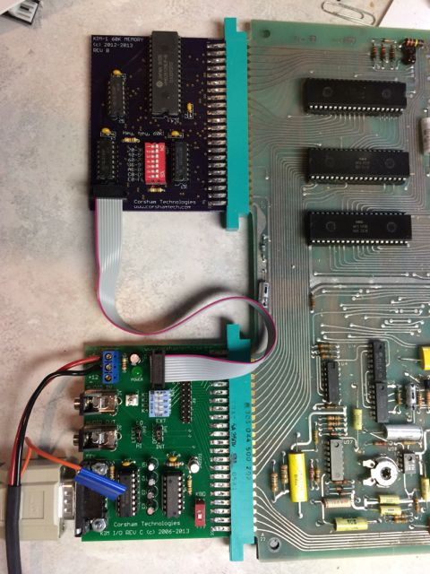

## Wiring It Up Yourself – Not as Easy

The 60K memory board plugs into the KIM-1’s Expansion bus, which is the bus on the upper left. It is not the one where you have power connected. This is the easiest part of the installation.

This board needs a bit more setup than some of our previous products because there are more control lines needed to control the external decoding. On the Application connector (the lower one) are a number of pins that are needed for the 60K board to operate:

|  |  |  |  |
| --- | --- | --- | --- |
| **Pin** | **Name** | **I/O** | **Use** |
| C | K1 | O | Low when 0400-07FF selected |
| D | K2 | O | Low when 0800-0BFF selected |
| E | K3 | O | Low when 0C00-0FFF selected |
| F | K4 | O | Low when 1000-13FF selected |
| K | DECOD ENAB | I | When low, the lower 8K of address space of the 6502 is selected. |

The default set-up of a KIM-1 is to wire pin K to ground, which always enables the on-board RAM, ROM and peripherals, but this pin will be fed from a pin on the 60K board. If an address in the lower 8K is selected, the 60K board will pull this low, otherwise it will be held high and the RAM board decodes the address.

The K1 to K4 lines are outputs from the KIM-1 when the address selected is in each of those blocks. These signals are normally not used on an unexpanded KIM-1, but the 60K board can use their state to fill in the RAM in the lower 8K bank.

The easiest way to connect this to your KIM-1 is via a 10 pin cable from a Corsham Technologies I/O Expander board, since that brings over all the important signals.

The 60K RAM board has a 10 pin connector which brings a few needed signals to/from the board. This is designed to plug into the 10 pin connector on our KIM-1 I/O Expander board, but that board is not required. Here are the pin numbers on the 10 pin connector and which pins on the KIM-1’s Application connector they should be connected to:

|  |  |  |
| --- | --- | --- |
| 10 Pin Header | Application Connector | Description |
| 1 | C, D, E, F | From KIM-1 K1-K4 lines to select 1K memory blocks in lower 8K block. Output from the KIM-1. |
| 2 | K | DECODE ENABLE from 60K Memory board, input to the KIM-1. Goes low when lower 8K address is selected. |
| 3-9 |  | No connection |
| 10 |  | Ground |

You can control which 8K blocks are assigned to RAM by use of the SW1 switches on the 60K Board. There are seven switches with hexadecimal page numbers next to them. To enable that block as RAM, slide the corresponding switch to the right (ON). If the switch is on the left, then that block will not be mapped to RAM. You can use other external PC boards to make use of those blocks not mapped to RAM.

# Interrupt Vectors

As noted earlier, interrupt vectors are mapped back to the default vectors in the KIM-1 ROMs, so there are no user writable vectors at FFFA-FFFF. Use the KIM-1 default RAM vectors at 17FA-17FF.

# Secrets, or How to Get Another 60K

The RAM chip is 128K, but only the lower 64K are used on the board as-is. If that seems like a waste, you can modify the board to enable the upper 64K via bank selection. This isn’t for the faint of heart, but here are some details.

First, you need to access the chip’s A16 line, pin 2. Right now it’s grounded to always select the lower 64K. By cutting the trace between ground and A16, and then bringing A16 to an unused I/O port you can select which bank by setting that I/O pin to 0 (lower 64K) or 1 (upper 64K). It would be a good idea to also pull this line high or low with a 1K or 2K resistor so it doesn’t just float if the I/O pin isn’t programmed.

If you implement this, keep in mind that the entire 60K is bank selected, so only the original RAM in the KIM-1 (0000 – 03FF) remains visible to both banks. You’ll have to write some bank select logic and place it into low RAM so it’s visible to code in both banks.

Why didn’t we do that? Because it adds yet another layer of confusion that people might not want to deal with, but it might be added in a future version, probably with a pull-up resistor to select bank 1 by default and then bring A16 to the 10 pin connector which can go back to the Application connector. Again, this might be added in a later version.

# Hey, Hey, 60K… Huh?

“Hey, Hey, 16K” is the name of a song written by MJ Hibbett about the good ol’ days of computers when 16K was enough memory to do many useful and fun things. I suggest you go to Wikipedia to see the entry for him and the link to the information about this particular song, or go to YouTube and search for “hey hey 16k.” One of many great lines:

*Hey, Hey, 16K, what does that get you these days?*

*You need more than that for a letter,*

*Old School Ram Packs are much better!*

Since “60K” sounds like “16K” I decided to pay homage to Mr. Hibbett’s great song and put that phrase on the board. I had seriously considered making a 16K board but that seemed kind of silly.

My KIM is calling me…

*Bob Applegate*

*March 2014*

# Revision History

|  |  |
| --- | --- |
| Version | Changes |
| A | Initial Beta. |
| B | Changed from jumper block to DIP switch. First prototypes and production run. |
| C | Moved around artwork to make it easier to read. Added part identification (part descriptions). |
| D | Fixed incorrect placement of labels on memory switch. |

# Errata

Rev A, B and C Boards: The DIP switch labels are in the wrong order:

|  |  |
| --- | --- |
| Label (incorrect) | Actual |
| 20-3F | E000-FFF7 |
| 40-5F | C000-DFFF |
| 60-7F | A000-BFFF |
| 80-9F | 8000-9FFF |
| A0-BF | 6000-7FFF |
| C0-DF | 4000-5FFF |
| E0-FF | 2000-3FFF |

# Parts List

|  |  |  |
| --- | --- | --- |
| Part | Number | Description |
| PCB | 1 | Printed Circuit Board (Corsham Tech) |
| P1 | 1 | 22/44 pin edge connector |
| C1-C4 | 4 | .1 uf cap, .2” spacing |
| R1-R3 | 3 | ¼ resistor, 680 ohms to 2.2K (all should work) |
| P2 | 1 | 2x5 pin shrouded header |
| SW1 | 1 | 7 position DIP switch |
| IC1 | 1 | 74LS08 |
| IC2 | 1 | 74LS145 |
| IC3 | 1 | 74LS133 |
| IC4 | 1 | 628128 128Kx8 static RAM |
|  | 1 | 14 pin IC socket for IC1 |
|  | 2 | 16 pin IC socket for IC2, IC3 |
|  | 1 | 32 pin IC socket for IC4 |